Email: theatrericochet@gmail.com
Instagram: ricochet_theatre
Twitter: ricochetheatre
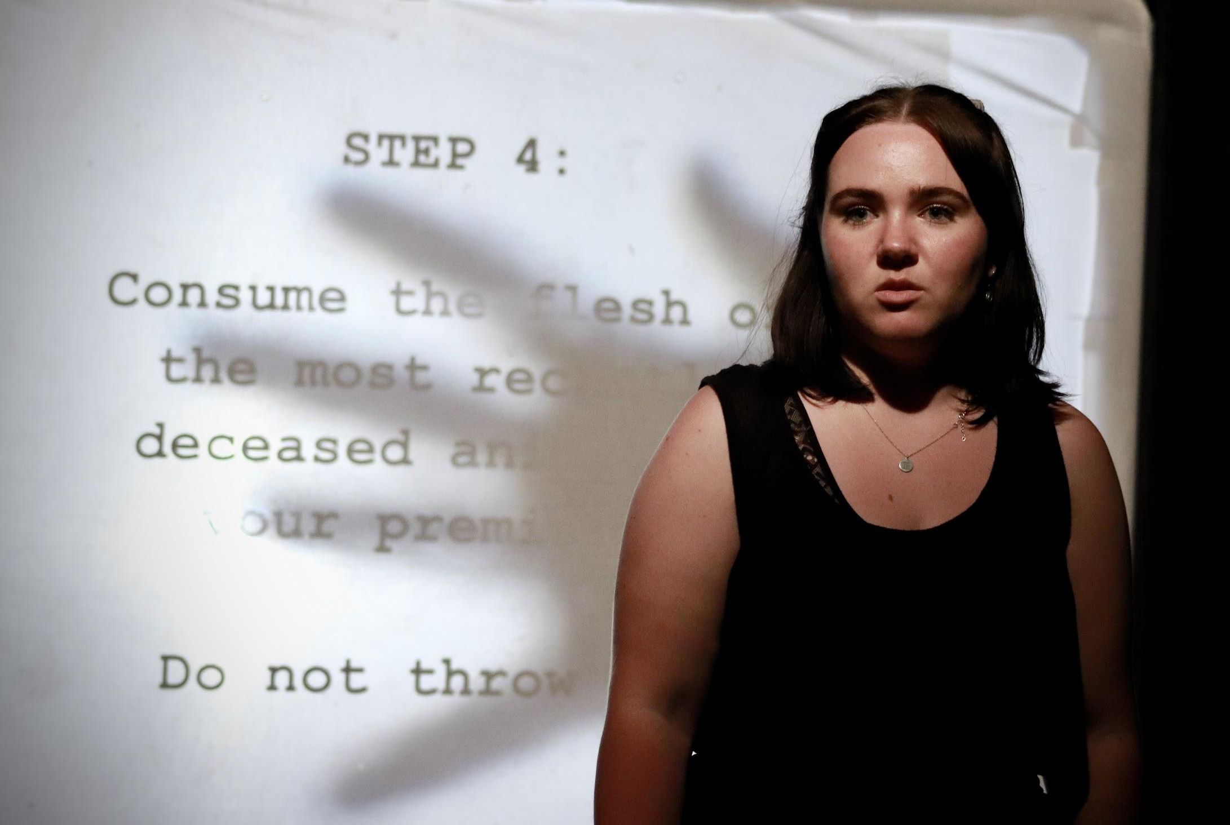
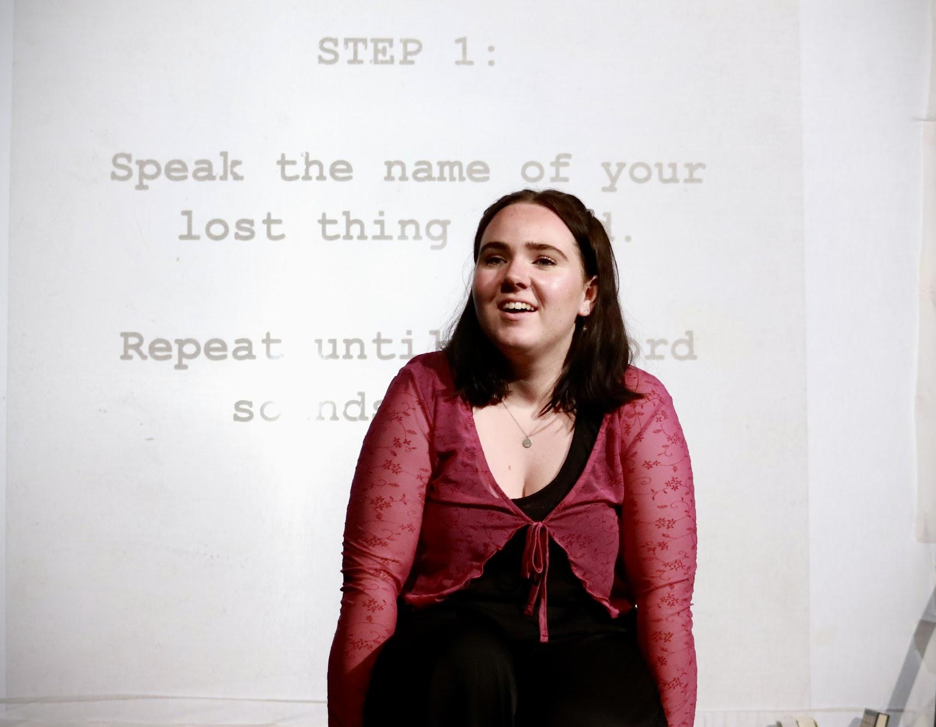
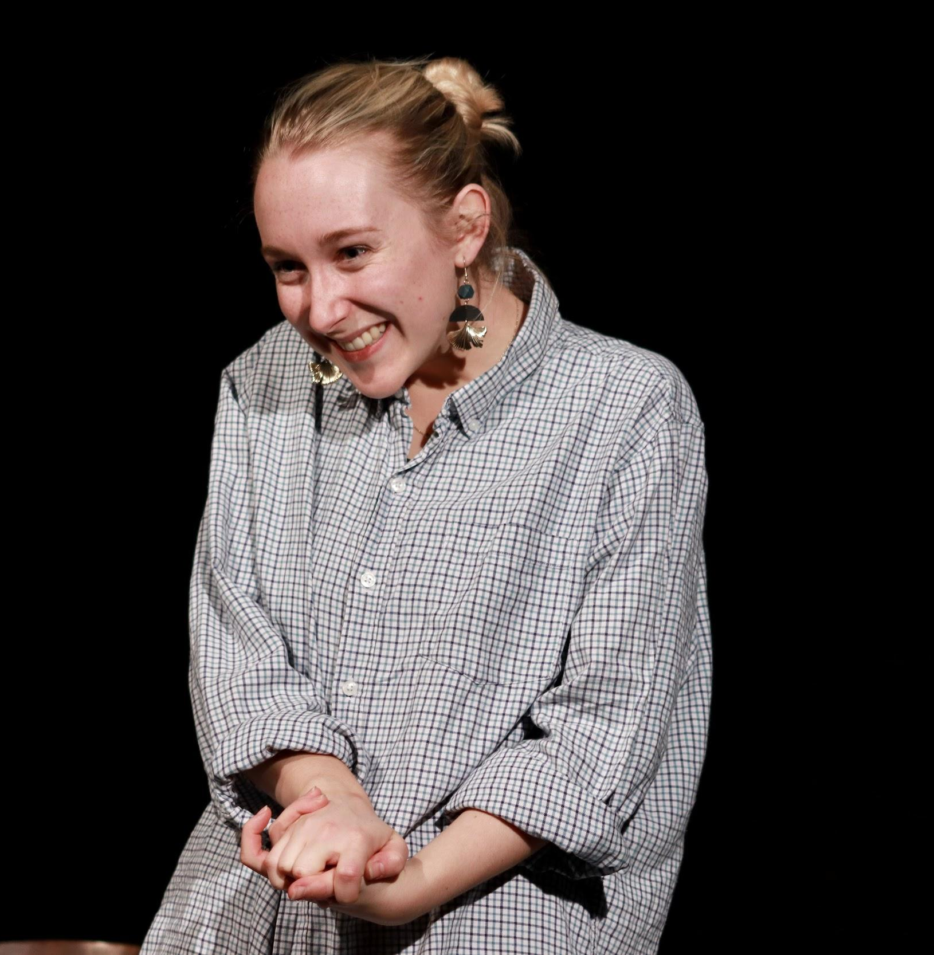
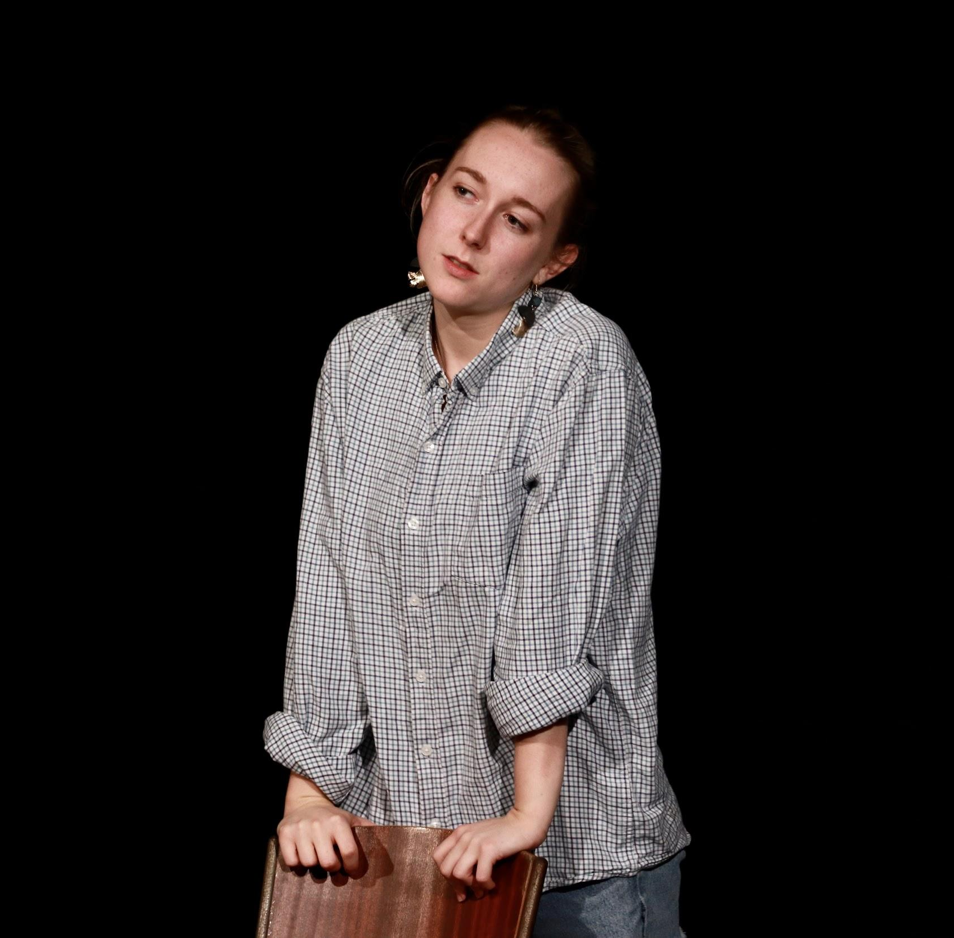
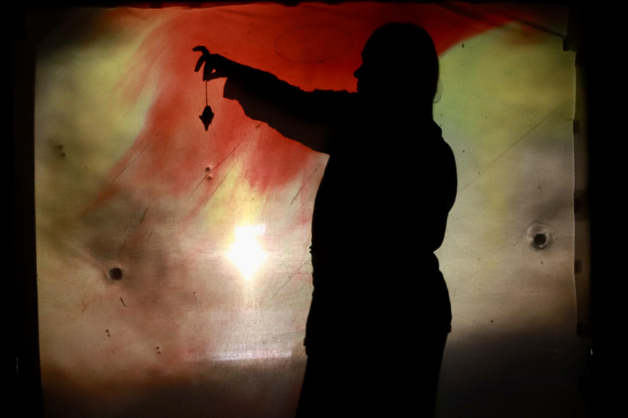

Two Monologues from Ricochet Theatre
Elegies
Ricochet Theatre presents a double bill of monologues navigating grief: Intricate Rituals by Seth Douglas and The Same Rain That Falls on Me by Logan Jones. Witness two intimate contrasting monologues that balance dark humour and touching pathos in equal measure.

Intricate Rituals

Siken is your average gay university student - witty, geeky and hopelessly in love with her straight best friend. But when callous, senseless tragedy unexpectedly strikes her life, Siken is forced to confront herself as grief turns her down a darker and increasingly supernatural path.
Deftly moving from comedy to tragedy, Intricate Rituals explores grief, unrequited love and the lasting effects of a closeted adolescence - and throws some interesting facts about bugs in there for good measure. Don’t miss this vulnerable and urgent performance directed by Ella McKeown with Maria Cook playing the role of Siken.

The Same Rain That Falls on Me

It’s the hottest day of the year and Alice is travelling home to say an untimely goodbye. One that will leave a hole in her life forever. The Same Rain That Falls On Me considers the connection between the effects of climate change on the planet and the effects of bereavement on a family, especially when that bereavement is avoidable. It’s a powerful and witty monologue about family, grief, and finding hope in the face of overwhelming uncertainty.

Directed by Jay Seldon and performed by Ella McKeown, The Same Rain That Falls On Me received the Pick of the Bedford Fringe award in July 2021 on Ricochet Theatre’s first ever tour.

Ricochet Theatre
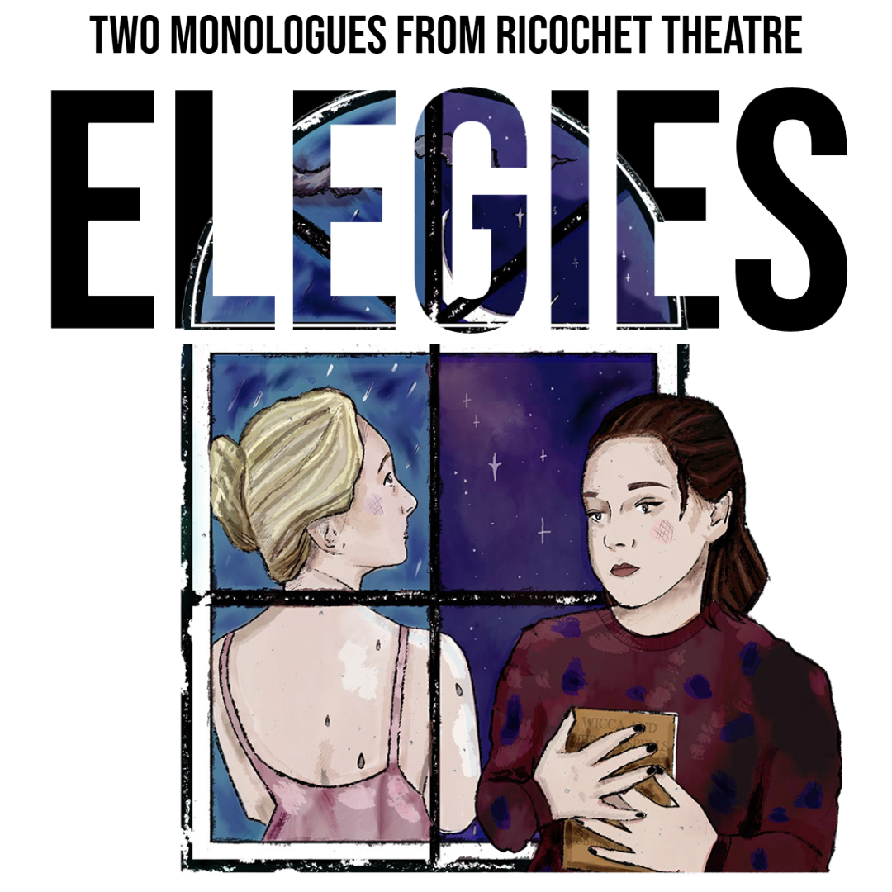
Elgies is produced by Ricochet Theatre, a fledgling theatre company dedicated to excavating under-represented, forgotten or mis-told stories. They are a low budget but big imagination company scattered all over the country conducting rehearsals both remotely on zoom and in their living rooms in person. Ricochet Theatre is proudly supported by the York Performance Award and 53 New.
Listings Information

Venue: Applecart Arts, The Passmore Edwards Building, 207 Plashet
Grove, London, E6 1BX
Dates: 18th, 19th and 20th November 2022
Time: 7:45pm
Length: 1 hour 35 minutes (including an interval)

